A server is a central repository where information and computer programs are held and accessed by the programmer within the network. **Web server** and **Application server** are kinds of the server which employed to deliver sites and therefore the latter deals with application operations performed between users and back-end business applications of the organization.

**Web Server:**It is a computer program that accepts the request for data and sends the specified documents. Web server may be a computer where the online content is kept. Essentially internet server is employed to host sites however there exist different web servers conjointly like recreation, storage, FTP, email, etc.

**Example of Web Servers:**

* Apache Tomcat
* Resin

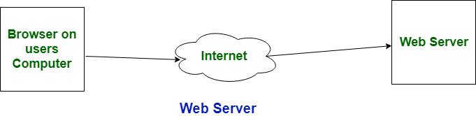

**Application server:** It encompasses Web container as well as EJB container. Application servers organize the run atmosphere for enterprises applications. Application server may be a reasonably server that mean how to put operating system, hosting the applications and services for users, IT services and organizations. In this, user interface similarly as protocol and RPC/RMI protocols are used.

**Examples of Application Server:**

* Weblogic
* JBoss
* Websphere

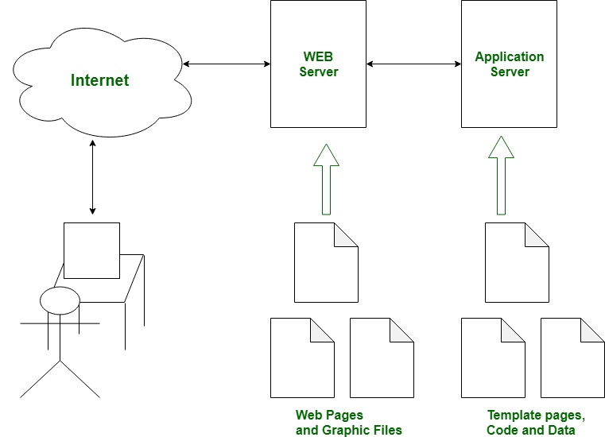

**Difference between web server and application server:**

|  |  |  |
| --- | --- | --- |
| S.NO | Web Server | Application Server |
| 1. | Web server encompasses web container only. | While application server encompasses Web container as well as EJB container. |
| 2. | Web server is useful or fitted for static content. | Whereas application server is fitted for dynamic content. |
| 3. | Web server consumes or utilizes less resources. | While application server utilize more resources. |
| 4. | Web servers arrange the run environment for web applications. | While application servers arrange the run environment for enterprises applications. |
| 5. | In web servers, multithreading is not supported. | While in application server, multithreading is supported. |
| 6. | Web server’s capacity is lower than application server. | While application server’s capacity is higher than web server. |

1)go into root folder and install apache by apt install apache command

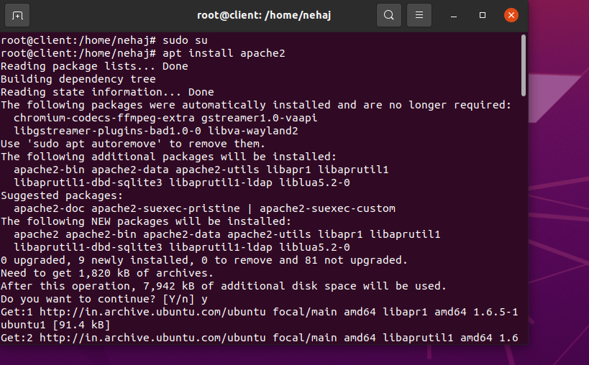

2)go into cd /var/www/html/



3)insert some text



4)install firewall by apt install firewalld

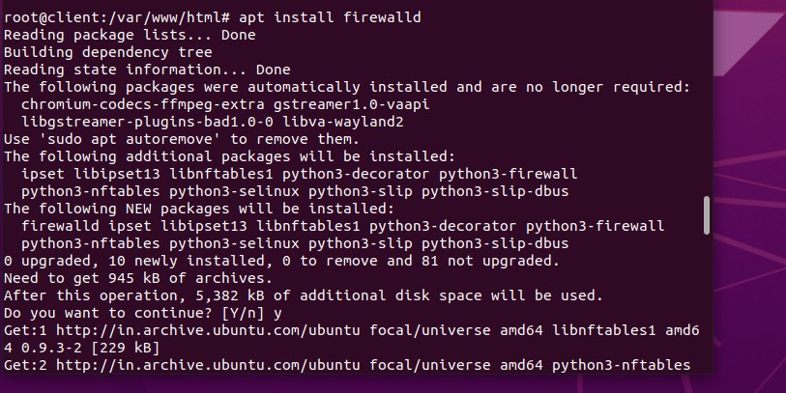

5)run firewall-cmd –permanent –add-service=http



6)restart apache

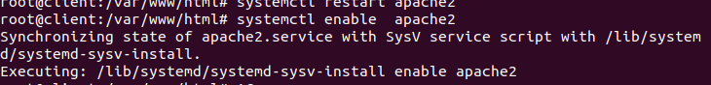

7)put ip address in browser and see the text

